### **Idea Analysis & Marketing**

***Regulatory Analysis***

***Legal Climate***

In The United States it is illegal to operate a betting scheme, except for in Nevada, Oregon, Delaware, and Montana (www.law.cornell.edu). New jersey also has relaxed gambling laws (www.law.cornell.edu). Most relevantly for WagerMe online sports betting is a criminal activity in Indiana (sportsbettingindiana.com). This has inspired WagerMe’s reward system. With WagerMe’s reward system neither party puts any risk into the transaction. Also WagerMe is not taking a cut of any bet, because it will be supported by advertising revenue and a potential monthly fee. This could potentially provide WagerMe protection from state and federal betting law. In order to further protect itself from sports betting law WagerMe could begin by not including sports betting. This version of the app would allow users to bet on their own personal competitions. According to Mark Alesia of the IndyStar, sports’ betting is trending heavily toward being legal nationally. There have even been bills put forth in Indiana to legalize sports betting at the casinos in the state (indystar.com). If WagerMe is able to be successful with its reward system then it could benefit from being an established app when sports’ betting becomes legal.

***Regulations and Governing Bodies***

Sports themselves have regulations that make betting on sports illegal. For example, when Pete Rose got caught gambling on baseball, the MLB enforced their regulations and punishments on Pete Rose. Major League Baseball, the National Football League and the National Basketball Association are all governing bodies of sports betting, but mainly for the players and coaches of those leagues.

Then you have federal and state laws that have been passed to regulate online betting. The Internet Wire Act is a law that was passed by the Supreme Court that states it is illegal to gamble and use wiring services online. Similarly, the Professional and Amateur Sports Protection Act is an act to prohibit sports gambling under state law. In both acts, the F.B.I. is more worried about large-scale operations rather than individual bets. For example, the F.B.I. would use these acts to shut down online sites that allow users to bet rather than the users themselves. However, because people are gambling illegally, if their betting service gets shut down, they would lose any money they have tied into the site.

Though WagerMe does not include any actual money, it still would be subject to these regulations and would be watched to ensure no illegal activity is being performed. The reward system WagerMe uses makes sure you can make bets and ensures that both the users and WagerMe are not performing any illegal activities.

***Licenses & Approvals***

There are no government required licenses needed for betting rewards points because it is not actual currency and won’t be used to redeem actual currency. From the rewards system, approvals would have to be made with companies whose products or services are redeemed by WagerMe users. Redeemable rewards are not limited to any specific types of products or services, but it would be expected that these rewards aren’t of significant value. Instead, the rewards would be intended to attract customers to the company offering the reward, or drive another aspect of their business in some way. For example, Chipotle could offer the reward of free chips and guacamole, which would help promote the sales of burritos or their other options. Essentially, WagerMe rewards are part of the marketing strategy for their own products. Starting out, WagerMe will focus on partnering with local businesses in college towns who would be more likely to approve of this model because it would be a simple marketing solution that would reach their target demographic as well. In this way, both WagerMe and the business offering the reward are benefitted. WagerMe will have to gain approval from the Apple App Store and Google Play Store for a license to publish the app on their stores. The App Store requires a $99/year fee, while the Play Store only requires a one-time $25 fee. The WagerMe app is expected to be approved by both stores based on their respective terms and conditions.

***Intellectual Property Protection Plan***

***Business Protections:***

WagerMe would need to protect the software and branding of the company, in addition the the personal/profile information of each and every user. As far as security, extensive measures will be taken during the development stages to ensure user’s information is kept private and secure. In addition, if virtual currency is utilized, the dangers of proprietary information (such as credit card information) being stolen is substantially lowered. Utilizing the advertisement revenue method will, in the end, lower business risks. To protect the business’s intellectual and digital property, all legalities will be followed and WagerMe will be trademarked. This will protect the names, term, and symbols that can be used to identify the company and/or its services. A provisional patent for the mobile application and its data will also be purchased, at a cost of about $2000.

***Competitors and Intellectual Property***

There are other peer to peer sports betting applications like WagerMe, however, none with the same concept. “YouBetMe” is a highly downloaded application that allows for peer to peer sports bets. “Bait” is another top app like YouBetMe, however, Bait focuses more on custom bets between acquaintances. Our application plans to combine both of these features as well as implementing our own currency which neither of these two currently do. Both instead use real money which is why they are downloaded less in the United States. Currently we are not as concerned about any one company having the same IP as us. Nonetheless in such a growing industry anything can change which is why we would have to get on app development quickly.

***Financial Analysis***

***Start Up Costs & Planning:***

Mobile Advertising as a means of monetizing allows for less startup costs than most new ventures. By integrating advanced payment services in our app such as mobile advertising we hope to make money as soon as our app hits the market. As well we may allow customers to get a premium version of the app that does not include ads, and rather offers monthly WagerPoints additions. Most of the startup costs will come from the development of the application as building the app will take some time. According to CNN, the total cost for building a mobile application can range from $10,000 - $200,000. It also states that a programmer, designer, and much more would need to be hired, which wouldn’t be cheap. Nonetheless, software development costs can be reduced if an entrepreneur on the team already has the technical skills to build the app. If no one on the team does than outsourcing app development may be a good option for the WagerMe team.

Here is a list of all startup costs that our teams will face.

1. App Development & Outsourcing - $10,000 - 1st year expense
2. Cost of Apple App Store Fee - $99/Year
3. Cost of Google Play Store Fee - $25 - 1st year expense
4. Cost of LLC - $49 - 1st year expense
5. Cost of Trademark for Electronic Applications- $275 - 1st year expense
6. Cost of Provisional Patent of Mobile Applications - $2,000 - 1st year expense
7. Cost of Marketing - Google Ads, Facebook Ads, Office Supplies - $10,000/year
8. Cost of Upkeep & Updating App - $1200/year following 1st year

***Projected Profits/Loss (3 Years)***

The online betting industry yields nearly $75 billion in earnings yearly (Statista). In addition, the largest companies in the industry (bet365 and William Hill) see profits of from $1.5 million to higher than $1 billion. William Hill, the largest sports betting company worldwide, holds roughly 38% of the market share in the UK. These numbers suggest the viability of entering the sports betting market either nationally or worldwide, especially as these numbers continue to grow.

The first year of the company will most likely see the lowest profits, as startup, operating, and software/application development expenses will be accounted for during this year. Even though these expenses will be low (projected under $25,000), the projected highest expenses will be during this first year and majority of costs will be avoided through team labor. We believe we can obtain 50,000 users within the first year. With this, the estimated revenue for the first year will be about $73,440, subjective to the ad revenue and the overall user interaction with the slotted advertisements. This number is based on an average monthly mobile ad revenue of $12,240 per 100,000 app users (*SmallBusiness)*. In addition, a pro version of the application (ad-free) could potentially bring in additional revenue for the more passionate users. The second and third years will see further growth of the industry (about 5.4% according to *EGBS Sports Betting Report*), and, in addition, the user base will grow via marketing campaigns, indicating a potential growth in revenue around 10%. In time, new and renewed advertisement contract prices can be raised. The second year should potentially expand the earnings up to $80,784. In the third year, the projected revenue would be roughly $88,862. Then, we expect a 10% growth for the following years. Expenses for year one will be $22,489 before any payouts, while the expenses of the following years would it would only be $11,299. These numbers will yield profits of roughly $32,078, $45,165, and $50,415, in the first, second, and third years, respectively. If able to gain a large stake in the worldwide betting industry, WagerMe could reach revenues closer to the revenue of Paddy Power Betfair (one of the largest companies) at $1B per year (Statista).

***Income Statement:*** Refer to attached WagerMe spreadsheet to see income statement.

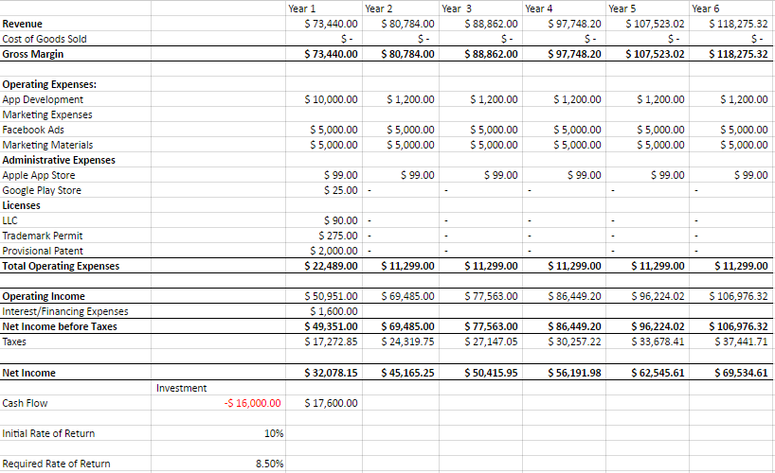

***Initial Investment & Break-Even Analysis:***

Based on the gross number of downloads that will be made for our application, some calculations need to be made to calculate the number of users required to reach break-even. Based on those same studies quoted above, $12.240 are generated per month on average for 100,000 users. Since our fixed cost for the first year are estimated at $ 22,489 and having no direct COGS for our products, we would need for that year 22489/(12240*12/100000)=15311 users on average.

Our fixed costs will represent $22,489 for the first year and about $11,300 for the following years. From year two, our fixed costs should be fund by the revenue generated in prior years. It means that our funding needs will represent $22,489. This is a relatively small amount for starting a business and it allows us to only focus on close sources of money. Indeed, we plan each of us to be responsible for a seventh of the initial capital, part of it will be our personal money and the other part will be brought be family members and friends. Altogether, our personal money will represent $14,000 and the rest of the initial capital ($30,000), which represent, $16,000 will be raised from third parties from our close friends and family members. Hence, each member of the team will need to raise one seventh of this amount that way. As a general rule, we plan to limit individual investments from third parties to $1,000 to set a policy that would limit their involvement in the company.

We expect the people from who we will obtain the money a normal rate or return in their everyday life of 8-9%. That is why we will offer them a slightly higher 10% return rate for being part of the project.

Their money will be reimbursed at the end of year 1 in order to limit the level of interest we will owe them. At the end, it represents a cost of $1,600 in year one.

***Investors’ Initial Rate of Return (IRR)***

Since only family members will invest money in our project, the IRR does not need to be very high. A 10% interest rate will already bring them a present net value of $221 based on different alternatives they may have at a 8-9% interest rate.

***Works Cited:***

http://www.indystar.com/story/news/2015/01/09/sports-gambling-indiana-legislature-fantasy-sports/21458829/

https://www.law.cornell.edu/wex/gambling

http://www.sportsbettingindiana.com

http://www.egba.eu/facts-and-figures/studies/6-sports-betting-report/

https://www.statista.com/topics/1740/sports-betting/

http://smallbusiness.chron.com/calculate-mobile-ad-revenue-74440.html

https://developer.android.com/google/play/licensing/index.html

https://developer.apple.com/programs/

http://www.cnn.com/2012/02/03/tech/mobile/building-mobile-apple-app/

https://www.richardspatentlaw.com/faq/how-much-does-it-cost-to-patent-a-mobile-app/

http://www.wordstream.com/blog/ws/2015/05/21/how-much-does-adwords-cost

https://www.gamblingsites.com/online-gambling-jurisdictions/us/

https://www.facebook.com/business/learn/how-much-facebook-ads-cost/

https://www.legalzoom.com/articles/how-much-does-it-cost-to-trademark-a-business-name